**CPP Notes – Day 01**

**Visual Studio Setup for C++ – Key Points**

1. Install Visual Studio with C++ Workload: Download from visual Microsoft website and select “Desktop development with C++” during installation.
2. Create a new C++ project: Go to File > New > Project. Choose Console App (C++) and set a name and location.
3. Write and run your code: Add your C++ code in main.cpp. Build and run your program.

**Operators**

Operators in C++ are symbols that perform operations on variables and values. They are fundamental to any programming language and can be classified into several types: Arithmetic, Relational, Logical, Assignment.

1. Arithmetic Operators: Used to perform basic mathematical operations.

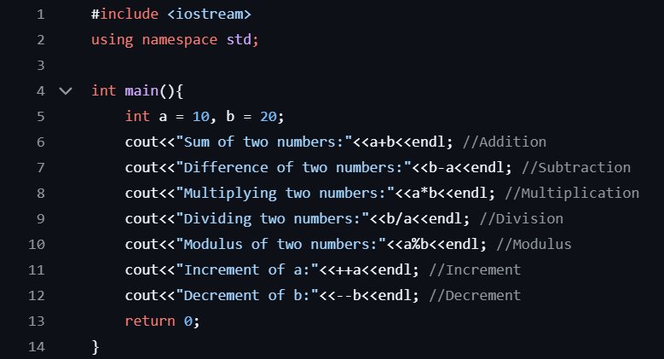

1. Assignment Operator: Used to assign values to variables.

1. Logical Operator: Used to combine multiple conditions.

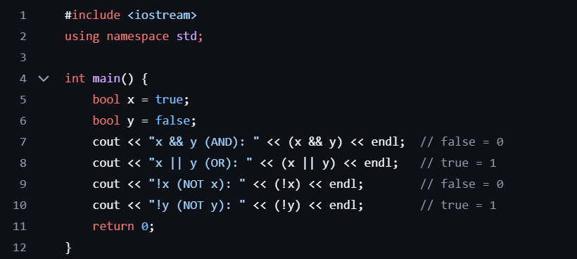

1. Comparison Operator: Used to compare values.

